BENGALURU NORTH UNIVERSITY

Tamaka Post, Kolar - 563103

Project Report
on
“VIRTUAL ASSISTANT WITH VOICE RECOGNITION”
Submitted in partial fulfillment of the requirements of Bachelor of Computer Application of Bengaluru North University
by
PAWAN GOWDA (U19LU22S0058)
CHIRANTHANA (U19LU22S0058)
Under the guidance of
Ms. Jeyarani.R

(Senior Assistant Professor)

New Horizon College Kasturi Nagar, Bengaluru– 560043.

CERTIFICATE

This is to certify that I PAWAN GOWDA (Reg No. U19LU22S0058) is the Bonafide student at New Horizon College and has carried out a project entitled “Virtual assistant with voice recognition” under the guidance of Senior Assistant Professor MS. JEYARANI.R. This project report has been submitted during the academic year 2025 in partial fulfillment of requirements of the Degree in Bachelor of Computer Application, Bangalore North University.

Date:
Place: NHCK, Bangalore

PROJECT COORDINATOR H.O.D PRINCIPAL

External Viva-voice Conducted on___________________

INTERNAL EXAMINER EXTERNAL EXAMINER

DECLARATION

I PAWAN GOWDA (Reg No. U19LU22S0058) do hereby declare that the project work entitled - “VIRTUAL ASSISTANT WITH VOICE RECOGNITION” is a Bonafide work carried out by me under the guidance of Senior Assistant Professor Ms. JEYARANI.R and Head of the department MS. UMA.P. This project is my original work and has not been presented to any other university. This project has been submitted as partial fulfillment of requirements for the Degree of Bachelor of Computer Application, Bengaluru North University.

Date : Signature of the candidate
Place : NHCK, Bengaluru

PAWAN GOWDA
U19LU22S0058

ACKNOWLEDGEMENT

It is a great pleasure to express my sincere gratitude to those who have contributed to my learning, through their support, encouragement and guidance.

I sincerely thank our Chairman Dr. MOHAN MANGHNANI, New Horizon College for providing me the necessary facilities for the completion of the project.

With great pleasure I place on record of my deep gratitude to our Principal Dr. BASAWARAJ
for providing all the facilities for the completion of the project.

I am grateful for the co-operation and valuable suggestions rendered by my guide MS. JEYARANI.R and Head of the Department MS. UMA.P, Professor, for their sincere assistance, valuable guidance and careful reviews, without which my effort would have been in vain. Thanks for the inspiration given to me in my task by her kind appreciation and suggestion through the project.

I also express my gratitude to all the faculty members of the Department of Computer Science. Finally, I would like to thank my parents and friends who have always been a great inspiration to the success of my project.

Yours Faithfully,
Pawan Gowda
U19LU22S0058

TABLE OF CONTENTS
SL. NO | CONTENTS | PAGE NO
 | - Certificate  - Student declaration  - Acknowledgement | 2
1 | INTRODUCTION TO THE PROJECT  - Introduction  - Module Description | 7
2 | SYSTEM ANALYSIS  - Importance  - Proposed System  - Advantages over existing systems  - System Workflow | 11
3 | SYSTEM REQUIREMENTS AND SPECIFICATIONS  Requirements specifications analysis  Hardware requirement specification  Software Requirement Specification  Goals of SRS  Python Programming Concepts  Functional and Non-Functional Requirements | 15
4 | SYSTEM DESIGN  - High-Level Architecture  - ER-diagram  - Flowchart | 26
5 | SOURCE CODE  - Python source code  - Libraries  - Function Definitions  - Graphical User Interfaces | 31
6 | TESTING AND  IMPLEMENTATION  Objectives of Testing  Testing Methodologies  Tools and Resources used  Testing Strategy and Approach  Testing outcomes and types | 45
7 | CONCLUSION  - Conclusion of the project  - Future Enhancements | 51
8 | BIBLIOGRAPHY  References  Websites | 55

INTRODUCTION TO THE PROJECT

SYNOPSIS

This project focuses on developing a Virtual Assistant with voice recognition capabilities using Python. The assistant is designed to interact with users through natural language, enabling hands-free operation and improving accessibility. It utilizes Python libraries such as speech_recognition for converting spoken words into text, pyttsx3 for text-to-speech output, and pyaudio for audio input. The assistant can perform various tasks, including answering questions, searching the web, opening applications, sending emails, telling the weather, delivering news updates, and managing daily schedules.

The assistant incorporates natural language processing (NLP) to understand and respond to user commands effectively. Additional features include integration with external APIs for real-time data retrieval (such as weather and news) and support for multi-language communication. The project also includes a graphical user interface (GUI) built with Tkinter, enhancing usability through visual feedback. The voice-driven interaction model makes the assistant suitable for smart environments, especially where keyboard or touch interaction is inconvenient. This virtual assistant showcases the potential of Python in building intelligent, user-friendly automation tools.

INTRODUCTION

In today’s fast-paced digital world, virtual assistants have become increasingly popular due to their ability to simplify tasks and enhance productivity through voice-based interaction. This project, Virtual Assistant with Voice Recognition Using Python, aims to develop an intelligent software assistant capable of understanding and responding to user commands through speech. With the rise of smart devices and artificial intelligence, voice-controlled systems offer a more natural and convenient way for users to interact with technology.

Alice is a Python-based virtual assistant developed to help users perform a variety of daily digital tasks using voice or text commands. The assistant features a visually appealing GUI and supports both voice recognition and text input. The goal is to provide an accessible and multifunctional tool for productivity, entertainment, and information retrieval.

The assistant is built using Python, a versatile and widely used programming language that supports various libraries for speech recognition, text-to-speech conversion, and natural language processing. By leveraging these tools, the assistant can perform a wide range of tasks, including providing weather updates, opening applications, searching the internet, sending messages or emails, and more—all controlled by voice commands.

This project not only demonstrates the practical application of Python in artificial intelligence but also highlights the potential of voice recognition technology to create more accessible and user-friendly computing experiences.

MODULE DESCRIPTION

This Python module implements a multifunctional voice-activated virtual assistant named Alice. It uses speech recognition and natural language processing to interpret user commands and execute various tasks. The assistant is built with several key libraries, including speech_recognition, pyttsx3, and tkinter, to enable voice input/output and a graphical user interface (GUI). The assistant operates via a central function that listens for a command, determines the user's intent using keyword-based matching, and calls the appropriate function to perform the task.

Key Features:

- Voice Interaction: Uses speech_recognition for capturing and interpreting spoken commands and pyttsx3 for generating voice responses.
- Natural Language Command Processing: Parses commands using regular expressions to identify the user's intent and map it to predefined actions.
- Web Services Integration: Supports web-based functionalities such as retrieving Wikipedia summaries, weather reports (via OpenWeatherMap API), and current news headlines (via GNews API).
- Media and Utility Functions: Allows playing and stopping music using VLC, reading PDF files, checking internet speed, performing basic arithmetic, and screen capturing.
- Communication Features: Sends emails using SMTP and WhatsApp messages using pywhatkit.
- App Control: Opens and closes installed applications using subprocesses and system commands.
- Graphical User Interface: Built using tkinter with an animated GIF background and interactive buttons for initiating voice interaction and exiting the assistant.

SYSTEM ANALYSIS

IMPORTANCE

System analysis is a critical phase in the software development life cycle that involves understanding and detailing the requirements, constraints, and functionalities of the system. In the case of the Alice Virtual Assistant, the system analysis process aimed to identify user needs, define system behavior, and ensure that the application architecture and modules align with the project’s objectives.

Traditional systems often lack comprehensive information about maids, making it challenging for service seekers to make informed decisions about their background, skills, and work history.
Local networks or specific agencies can limit the available candidates, reducing the chances of finding the best match for the job.
Limited direct communication between service seekers and providers often leads to misunderstandings and unmet expectations, as there is no structured platform for ongoing communication and feedback.
The reliability and credibility of maids are difficult to verify, leading to trust issues between service seekers and providers due to inconsistent availability and verifiability of background checks and references.

PROPOSED SYSTEM
The proposed system, named Alice, is an intelligent, voice-activated virtual assistant designed using Python that provides a wide range of features aimed at automating everyday computer tasks. Unlike traditional assistants limited by platform dependency or lack of customization, Alice is a desktop-based assistant equipped with a friendly GUI, multi-language capabilities, and the ability to understand and process natural language commands.
The system is built to provide users with a seamless interaction experience via both voice and text, offering hands-free operation while maintaining accuracy and responsiveness.

Key Features of the Proposed System
• Voice and Text Input Modes
• Graphical User Interface (GUI)
• Text-to-Speech (TTS) using gTTS
• Speech Recognition
• Modular Functional Architecture
• Multi-language Support
• Extensibility

Advantages Over Existing Systems
Feature | Existing Assistants | Alice Virtual Assistant
Platform Independence | Platform-bound (iOS, Windows only) | Runs on any system with Python
Open Source and Customizable | No | Yes
Local Application Control | Limited | Full access to local apps
GUI with Visual Feedback | Minimal | Yes, with animation support

System Workflow
• Start – Launch Alice GUI.
• User Input – User provides a command via voice or text.
• Speech-to-Text (if voice) – Converts spoken input into text.
• Command Processing – Natural Language Understanding and command matching.
• Task Execution – Executes task (e.g., send email, fetch weather).
• Voice Output – Provides response through gTTS.
• End or Wait for Next Input – Assistant waits for the next command.

Technologies Used
Technology | Purpose
Python | Core programming language
Tkinter | GUI development
gTTS | Text-to-speech synthesis
speech_recognition | Capturing and converting voice input
pywhatkit | WhatsApp messaging and YouTube search
smtplib | Email automation
pyautogui | GUI automation and interactions
requests | API calls (weather, news)

SOFTWARE REQUIREMENTS AND SPECIFICATIONS

REQUIREMNTS SPECIFICATION ANALYSIS
A System Requirements Specification is a comprehensive description of the intended purpose, functionalities, and constraints of a software system. It serves as a formal agreement between stakeholders and developers, clearly outlining the expectations for the software. The SRS document acts as a guide throughout the development lifecycle, helping to ensure that the final product meets user needs and adheres to technical requirements.

Purpose
The purpose of this project is to develop a Virtual Assistant named Alice that can interact with users via voice and text input. Alice can perform various tasks such as fetching information from Wikipedia, playing music, opening applications, reading PDFs, checking weather and news, sending emails and WhatsApp messages, and more. The assistant is designed to assist users in daily tasks efficiently using natural language commands.

Scope
The system will operate on a desktop environment with a graphical user interface (GUI) built using Python's Tkinter. It will support voice input using speech recognition and output using text-to-speech (gTTS). The system integrates various APIs and libraries for weather updates, news headlines, PDF reading, internet speed tests, and other functionalities. The system is intended for users with basic computing skills who want to automate or simplify their interactions with their computer.

HARDWARE REQUIREMENT SPECIFICATION
The Virtual Assistant project “Alice” requires the following hardware components to ensure smooth and efficient operation:

Processor:
Minimum: Intel Core i3 (or equivalent AMD) processor
Recommended: Intel Core i5 or higher for faster processing and voice recognition

RAM:
Minimum: 4 GB RAM
Recommended: 8 GB or more to handle multitasking and GUI operations without lag

Storage:
Minimum: 10 GB free disk space to store temporary audio files, music files, and other resources
Recommended: SSD for faster file access and better overall system responsiveness

Audio Input:
A good quality microphone (built-in or external) capable of capturing clear voice commands for accurate speech recognition Audio

Output:
Speakers or headphones to play audio responses, music, and other sounds

Display:
Minimum: 1024x768 resolution for displaying the GUI interface properly
Recommended: Full HD (1920x1080) or higher for better user experience

Internet Connectivity:
A stable broadband or Wi-Fi connection to access online services such as weather API, news API, YouTube, Google, and WhatsApp messaging

Additional Peripherals:
Optional webcam if future features such as face recognition or video calls are planned
SOFTWARE REQUIREMENT SPECIFICATION

The Software Requirement Specification outlines the necessary software components, tools, and frameworks needed for the successful development and operation of the Voice-Based Virtual Assistant system.

Operating System
- Windows 10 or higher (for development and deployment)
- Cross-platform compatibility (Linux and macOS) with minimal modifications

Programming Language
- Python 3.8 or higher

Development Environment
- Visual Studio Code / PyCharm (for code development)
- Command Line Interface (CMD/Terminal) for script execution and testing

Python Libraries and Modules
Library | Purpose
speech_recognition | Converts spoken input to text
gTTS | Convert text output to speech
pyttsx3 | Offline text-to-speech support
pywhatkit | Automates WhatsApp, YouTube, and Google Search
wikipedia | Fetches concise summary data
requests | Sends HTTP requests to access APIs (weather, news, etc.)
pyautogui | Automates screen control and screen recording
vlc | Plays multimedia content
PyPDF2 | Extracts and reads content from PDF files
psutil | Retrieves information on running processes and system utilization
tkinter | Used for building Graphical User Interface (GUI)
newsapi-python | Fetches real-time news articles
speedtest-cli | Measures internet speed
pillow (PIL) | Processes and manages animated backgrounds or images
smtplib | Send email messages via SMTP

External APIs
- OpenWeatherMap API – For fetching current weather details
- NewsAPI – For retrieving news headlines
- Google APIs (used indirectly via pywhatkit)

Software Utilities
- VLC Media Player (external installation required for python-vlc integration)
- Google Chrome or default web browser
- Email service (Gmail with App Password enabled for SMTP)

Network Requirements
- Stable internet connection for online functionalities such as:
  - Weather and news updates
  - YouTube search and playback
  - WhatsApp messaging
  - Email sending

Goals of SRS:
The primary goals of the Software Requirements Specification (SRS) document for the Virtual Assistant project, Alice, are:

- Clear Definition of Functionalities: To clearly specify the functionalities Alice will provide, such as voice command recognition, web search, email and WhatsApp messaging, weather updates, news retrieval, PDF reading, music playback, app control, internet speed testing, and more.

- Effective Communication: To establish a common understanding between stakeholders (developers, users, and project supervisors) about what Alice is expected to perform, ensuring expectations are aligned.

- Foundation for System Design: To serve as a detailed reference for the development team during design and implementation, guiding the creation of Alice’s modules, GUI, and integration with APIs and external services.

- Scope Clarification: To explicitly define what features Alice will support and what falls outside the scope, preventing scope creep and focusing development efforts on core functionalities.

- Basis for Testing: To provide measurable and testable requirements that can be used during system validation to ensure Alice performs accurately, including speech recognition accuracy, correct execution of commands, and GUI responsiveness.

- Project Management Aid: To assist in planning the development phases, assigning tasks, and estimating resources and timelines based on clearly stated requirements.

PERT CHART
A Program Evaluation Review Technique chart provides a visual representation of a project's timeline, showing the sequence of tasks, their dependencies, and the estimated duration for each activity.

Planning and Scheduling
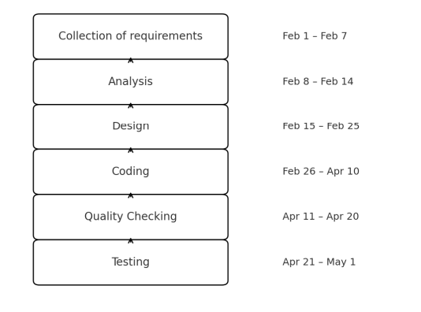
Python Programming
Python is a widely used high-level, general-purpose, interpreted, dynamic programming language. Its design philosophy emphasizes code readability, and its syntax allows programmers to express concepts in fewer lines of code than would be possible in languages such as C++ or Java. The language provides constructs intended to enable clear programs on both a small and large scale. Python supports multiple programming paradigms, including object-oriented, imperative and functional programming or procedural styles. It features a dynamic type of system and automatic memory management and has a large and comprehensive standard library. Python interpreters are available for installation on many operating systems, allowing Python code execution on a wide variety of systems
Scripting Language
A scripting or script language is a programming language that supports scripts, programs written for a special run-time environment that automate the execution of tasks that could alternatively be executed one-by-one by a human operator. Scripting languages are often interpreted (rather than compiled). Primitives are usually the elementary tasks or API calls, and the language allows them to be combined into more complex programs. Environments that can be automated through scripting include software applications, web pages within a web browser, the shells of operating systems (OS), embedded systems, as well as numerous games. A scripting language can be viewed as a domain-specific language for a particular environment; in the case of scripting an application, this is also known as an extension language. Scripting languages are also sometimes referred to as very high-level programming languages, as they operate at a high level of abstraction, or as control languages.

Object Oriented Programming Language

Object-oriented programming (OOP) is a programming paradigm based on the concept of "objects", which may contain data, in the form of fields, often known as attributes; and code, in the form of procedures, often known as methods. A distinguishing feature of objects is that an object's procedures can access and often modify the data fields of the object with which they are associated (objects have a notion of "this" or "self"). In OO programming, computer programs are designed by making them out of objects that interact with one another. There is significant diversity in object oriented programming, but most popular languages are class-based, meaning that objects are instances of classes, which typically also determines their type.

History of Python
Python was conceived in the late 1980s, and its implementation was started in December 1989 by Guido van Rossum at CWI in the Netherlands as a successor to the ABC language (itself inspired by SETL) capable of exception handling and interfacing with the Amoeba operating system. Van Rossum is Python's principal author, and his continuing central role in deciding the direction of Python is reflected in the title given to him by the Python community.

“Python is an experiment in how much freedom programmers need. Too much freedom and nobody can read another's code; too little and expressiveness is endangered. - Guido van Rossum.

Behind The Scenes of Python
About the origin of Python, Van Rossum wrote in 1996:
Over six years ago, in December 1989, I was looking for a "hobby" programming project that would keep me occupied during the week around Christmas. My office ... would be closed, but I had a home Computer, and not much else on my hands. I decided to write an interpreter for the new scripting language I had been thinking about lately: a descendant of ABC that would appeal to Unix/C hackers. I chose Python as a working title for the project, being in a slightly irreverent mood (and a big fan of Monty Python's Flying Circus).
Functional Requirements:
The functional requirements define the core services the system must deliver. For the Python-based
Virtual Assistant (Alice), the following functions are required:

- Input Handling
  - The system must accept user input via two modes:
    - Voice input using a microphone.
    - Text input via a GUI-based text field.
- Speech Recognition
  - Convert spoken input into text using the SpeechRecognition library and compatible speech engines such as Google Web Speech API.
- Command Interpretation
  - Analyse the user input (text or speech) using a set of predefined keywords, patterns, or Natural Language Processing (NLP) to interpret intent.
  - Match interpreted intent with the appropriate system action.
- Text-to-Speech Output
  - Use Google Text-to-Speech (gTTS) to convert textual responses into speech.
  - Playback the audio response using a system media player or playsound.
- Graphical User Interface (GUI)
  - Display a user-friendly GUI using Tkinter.
  - Include an animated background (e.g., GIF).
  - Provide visual status updates (e.g., "Listening", "Processing", "Responding").
- API Integration
  - Fetch and present real-time data:
    - Weather updates via OpenWeatherMap API.
    - News headlines via a suitable news API.
- Communication Features
  - Send Emails through SMTP using user credentials.
  - Send WhatsApp messages using tools like pywhatkit.
- Utility Tasks
  - Perform basic and advanced system tasks such as:
    - Mathematical calculations using eval or custom parser.
    - Launching desktop applications (e.g., Notepad, Chrome).
    - Running an internet speed test using speedtest-cli.
    - Reading PDF documents using PyPDF2.
- Language Support
  - Respond in multiple languages (e.g., English, Japanese), depending on user preference or command.

Non-Functional Requirements
- Performance
  - The assistant should provide responses with a delay not exceeding 2 seconds under normal conditions.
- Reliability
  - The system must be robust with error handling to manage:
    - API failures.
    - Invalid inputs.
    - Network issues.
  - Should automatically restart or prompt for retry on critical failures.
- Usability
  - The GUI should be clean and intuitive.
  - Voice input should work with natural, conversational commands.
  - Provide clear audio and visual feedback for each user interaction.
- Scalability
  - The architecture should allow easy integration of new features (e.g., alarm, calendar sync).
  - Use modular design with separate modules for speech recognition, command processing, etc.
- Portability
  - The system should run seamlessly on any Windows OS with required dependencies installed (e.g., Python, libraries).
  - Can be packaged into an executable using PyInstaller or similar.
- Maintainability
  - Configuration files and dependency lists (requirements.txt) should be provided for easy setup.
- Security
  - User credentials (for email, etc.) should be securely stored or encrypted.
  - Validate all inputs to prevent injection or unexpected behavior.

SYSTEM DESIGN
System Design
System design is the process of defining the architecture, components, modules, interfaces, and data flow for a system to satisfy specified requirements. For the virtual assistant project, the system is designed to integrate speech recognition, text-to-speech, a graphical user interface, and backend logic to perform various tasks.

High-Level Architecture
The virtual assistant system is composed of the following high-level components:

- Input Layer
  - Voice Input: Captured via microphone and processed using the SpeechRecognition library.
  - Text Input: Entered via a GUI text field.

- Processing Layer
  - Speech-to-Text Engine: Converts voice input to text.
  - Command Parser: Interprets user text using NLP and keyword matching.
  - Action Handler: Maps parsed commands to specific functions.
  - API Manager: Interfaces with external APIs (e.g., weather, news).

- Output Layer
  - Text-to-Speech (gTTS): Converts assistant responses into audio.
  - Media Playback: Plays audio response through system audio.
  - GUI Display: Shows text output and animations to enhance UX.

- Utility Modules
  - Email Sender: Sends emails via SMTP.
  - WhatsApp Messenger: Sends messages via pywhatkit.
  - PDF Reader: Reads and summarizes PDF documents.
  - Speed Tester: Measures internet speed using speedtest.
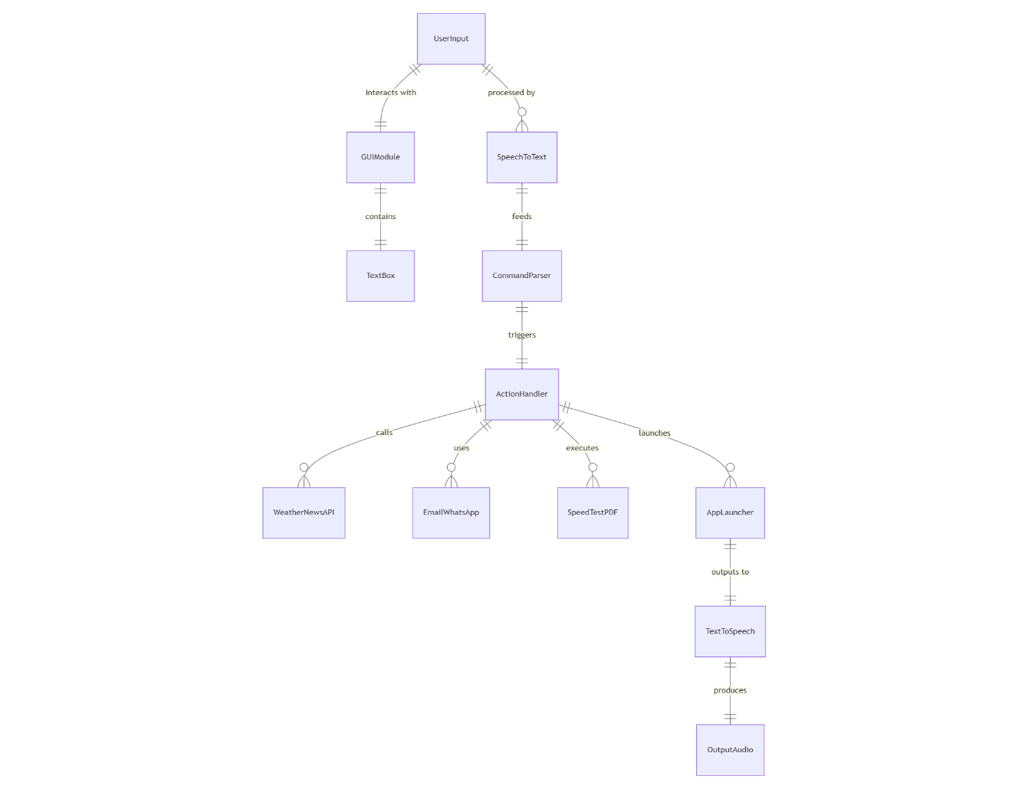
ER DIAGRAM
VIRTUAL ASSISTANT USING PYTHON
VIRTUAL ASSISTANT GUI
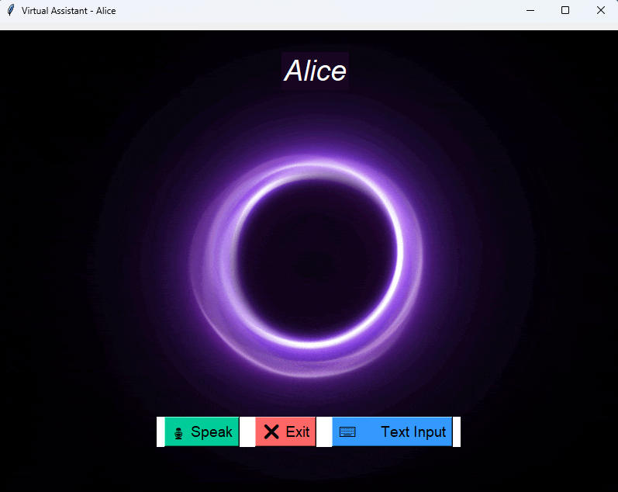
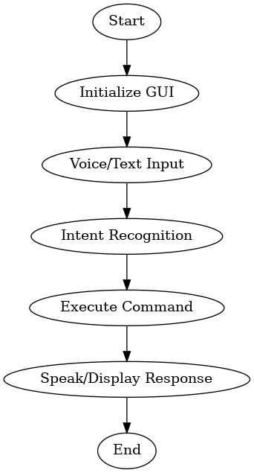
FLOWCHART
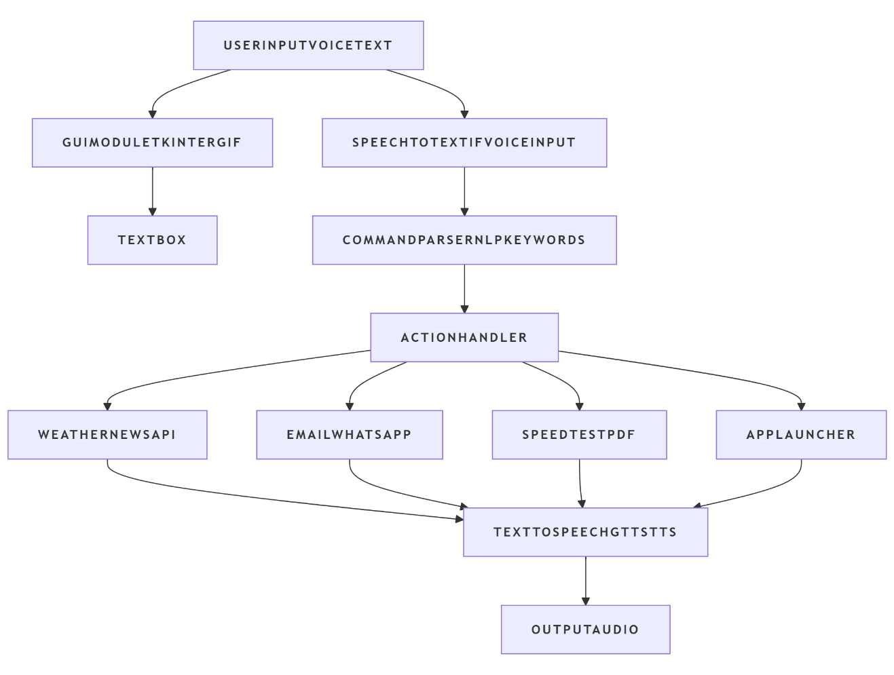

SOURCE CODE

Python Programming

from gtts import gTTS
import speech_recognition as sr
import datetime
import wikipedia
import webbrowser
import os
import re
import smtplib
import pywhatkit
import tkinter as tk
from tkinter import scrolledtext, simpledialog
from PIL import Image, ImageTk, ImageSequence
from tkinter import filedialog
import requests
import speedtest
import PyPDF2
import psutil
import pyautogui
import time
import subprocess
import operator
import vlc
import playsound
import random
import speedtest
from newsapi import NewsApiClient

player = None
music_folder = r"D:\College\Projects\Project\Music"

def speak(text):
tts = gTTS(text=text, lang='en', slow=False )
filename = "temp.mp3"
tts.save(filename)
playsound.playsound(filename)
os.remove(filename)

def take_command():
r = sr.Recognizer()
with sr.Microphone() as source:
print("Listening...")
audio = r.listen(source)
try:
command = r.recognize_google(audio, language='en')
print(f"You: {command}")
return command.lower()
except Exception as e:
# Instead of just returning "", raise to catch outside
raise e

def recognize_intent(text):
# (same intent recognition as before)
if re.search(r'\b(wikipedia|who is|tell me about)\b', text):
return 'wikipedia'
elif 'youtube' in text:
return 'youtube'
elif 'google' in text:
return 'google'
elif 'time' in text:
return 'time'
elif 'date' in text:
return 'date'
elif 'code' in text:
return 'open_code'
elif 'exit' in text or 'quit' in text:
return 'exit'
elif 'open' in text and '.com' in text:
return 'open_website'
elif 'send email' in text:
return 'send_email'
elif 'send whatsapp' in text or 'whatsapp message' in text:
return 'send_whatsapp'
elif 'weather' in text or 'temperature' in text:
return 'weather'
elif 'news' in text:
return 'news'
elif 'read pdf' in text:
return 'read_pdf'
elif 'open app' in text:
return 'open_app'
elif 'close app' in text:
return 'close_app'
elif 'play music' in text:
return 'play_music'
elif 'stop music' in text:
return 'stop_music'
elif 'screen record' in text:
return 'screen_record'
elif 'internet speed' in text or 'check internet speed' in text:
return 'internet_speed'
elif 'calculate' in text:
return 'calculate'
return 'unknown'

def read_pdf():
try:
pdf_path = filedialog.askopenfilename(title="Select PDF file", filetypes=[("PDF files", "*.pdf")])
if not pdf_path:
speak("No PDF file selected.")
return
with open(pdf_path, 'rb') as file:
reader = PyPDF2.PdfReader(file)
if len(reader.pages) == 0:
speak("This PDF is empty.")
return
text = reader.pages[0].extract_text()
if text.strip():
speak(text)
else:
speak("Could not extract text from the first page.")
except Exception as e:
speak("Failed to read PDF.")
print(e)

def play_music(volume=70):
global player
try:
songs = [os.path.join(music_folder, f) for f in os.listdir(music_folder) if f.endswith('.mp3')]
if not songs:
speak("No music files found.")
return
song = random.choice(songs)
player = vlc.MediaPlayer(song)
player.audio_set_volume(volume) # Adjust volume here
player.play()
speak(f"Playing {os.path.basename(song)} at volume {volume}")
except Exception as e:
speak("Failed to play music.")
print(e)

def stop_music():
global player
if player:
player.stop()
speak("Music stopped.")
else:
speak("No music is playing.")

def adjust_volume(volume):
global player
if player:
player.audio_set_volume(volume)
speak(f"Volume set to {volume}")
else:
speak("No music is playing, can't adjust volume.")

def open_app():
speak("Please tell me the app name to open.")
app_name = take_command()
if app_name:
try:
# Basic mapping, extend as needed
apps = {
"notepad": "notepad.exe",
"calculator": "calc.exe",
"chrome": r"C:\Program Files\Google\Chrome\Application\chrome.exe",
"vlc": r"C:\Program Files\VideoLAN\VLC\vlc.exe",
}
path = apps.get(app_name.lower())
if path:
subprocess.Popen(path)
speak(f"Opening {app_name}")
else:
speak(f"Sorry, I don't know how to open {app_name}")
except Exception as e:
speak(f"Failed to open {app_name}")
print(e)
else:
speak("No app name detected.")

def close_app():
speak("Please tell me the app name to close.")
app_name = take_command()
if app_name:
try:
for proc in psutil.process_iter():
if app_name.lower() in proc.name().lower():
proc.kill()
speak(f"{app_name} has been closed.")
return
speak(f"{app_name} is not running.")
except Exception as e:
speak(f"Failed to close {app_name}")
print(e)
else:
speak("No app name detected.")

def screen_record():
speak("Recording will start now for 5 seconds.")
time.sleep(1)
screen = pyautogui.screenshot()
screen.save("screenshot.png")
speak("Screen recorded and saved as screenshot.png.")

def get_weather(city):
api_key = "e2ae2655b7f23ebb21a794597a94a6ba" # <-- Replace with your OpenWeatherMap API key
base_url = f"http://api.openweathermap.org/data/2.5/weather?q={city}&appid={api_key}&units=metric"
try:
response = requests.get(base_url)
data = response.json()
if data["cod"] != 200:
speak("Sorry, I couldn't find the weather for that city.")
return
weather_desc = data["weather"][0]["description"]
temp = data["main"]["temp"]
humidity = data["main"]["humidity"]
weather_report = f"The weather in {city} is {weather_desc} with a temperature of {temp} degree Celsius and humidity of {humidity} percent."
speak(weather_report)
except Exception as e:
speak("Sorry, I couldn't retrieve the weather information.")

def internet_speed():
try:
response = requests.get("https://api.fast.com/netflix-speedtest")
data = response.json()
download_speed = data['download'] / 1_000_000

speak(f"Download speed is {download_speed:.2f} megabits per second.")

except Exception as e:
speak("Failed to get internet speed using Fast.com API.")
print(f"Error: {e}")

def calculate():
speak("Please tell me the math expression to calculate.")
expr = take_command()
if expr:
try:
# Remove words and keep numbers/operators
expr = expr.lower()
expr = expr.replace('x', '*').replace('into', '*').replace('plus', '+').replace('minus', '-').replace('divide', '/')
# Only allow digits and operators
expr = re.sub(r'[^0-9\+\-\*\/\.\(\) ]', '', expr)
result = eval(expr)
speak(f"The result is {result}")
except Exception as e:
speak("Sorry, I couldn't calculate that.")
print(e)
else:
speak("No expression detected.")

def get_news():
api_key = "9094c80893384cf08f3afb6929a75ee4"
url = f"https://newsapi.org/v2/top-headlines?country=us&category=business&apiKey={api_key}"

try:
response = requests.get(url)
news_data = response.json()

if news_data["status"] != "ok" or not news_data["articles"]:
speak("Sorry, I couldn't fetch the news.")
return

speak("Here are the top news headlines.")
for i, article in enumerate(news_data["articles"][:5], start=1):
speak(f"Headline {i}: {article['title']}")
time.sleep(1) # Slight delay between headlines

except Exception as e:
print(f"Error: {e}")
speak("Sorry, there was an error fetching the news.")
# (Keep your other function definitions unchanged: read_pdf, open_app, close_app, play_music, stop_music, screen_record, internet_speed, calculate, get_weather, get_news...)

def process_command(text=None):
"""
If text is None, tries to get voice input.
Else uses text directly.
"""
if text is None:
# Try voice input
try:
query = take_command()
except Exception:
# Mic failed, fallback to text input popup
speak("Microphone is not working. Please type your command.")
query = simpledialog.askstring("Input", "Type your command:")
if not query:
speak("No command entered.")
return
else:
query = text

intent = recognize_intent(query.lower())

if intent == 'wikipedia':
topic = re.sub(r"(wikipedia|who is|tell me about)", "", query, flags=re.IGNORECASE).strip()
try:
result = wikipedia.summary(topic, sentences=2)
speak(result)
except Exception as e:
speak("Sorry, I couldn't find that.")
elif intent == 'weather':
speak("Please tell me the city name.")
city = take_command() if text is None else None
if city is None:
# fallback to input box
city = simpledialog.askstring("Input", "Enter city name for weather:")
if city:
get_weather(city)
else:
speak("I didn't catch the city name.")
elif intent == 'youtube':
speak("Opening YouTube")
webbrowser.open("https://youtube.com")
elif intent == 'google':
speak("Opening Google")
webbrowser.open("https://google.com")
elif intent == 'time':
speak(f"The time is {datetime.datetime.now().strftime('%H:%M:%S')}")
elif intent == 'date':
speak(f"Today's date is {datetime.datetime.now().strftime('%Y-%m-%d')}")
elif intent == 'open_code':
code_path = "C:\\Path\\To\\Your\\Code.exe"
try:
os.startfile(code_path)
except Exception as e:
speak("Code editor path is not set correctly.")
elif intent == 'open_website':
site = query.split("open")[-1].strip()
if not site.startswith("http"):
site = "https://" + site
speak(f"Opening {site}")
webbrowser.open(site)
elif intent == 'send_email':
speak("What should the email say?")
content = take_command() if text is None else None
if content is None:
content = simpledialog.askstring("Input", "Enter email content:")
to = "fexota8432@nomrista.com"
try:
server = smtplib.SMTP('smtp.gmail.com', 587)
server.starttls()
server.login('pawangowda1326@gmail.com', 'hnzh pjal ojrs ofds')
server.sendmail('pawangowda1326@gmail.com', to, content)
server.quit()
speak("Email has been sent.")
except Exception as e:
speak("Sorry, I couldn't send the email.")
print(e)
elif intent == 'send_whatsapp':
speak("What should the message say?")
message = take_command() if text is None else None
if message is None:
message = simpledialog.askstring("Input", "Enter WhatsApp message:")
speak("Please say the phone number including country code, like plus nine one...")
phone_number = take_command() if text is None else None
if phone_number is None:
phone_number = simpledialog.askstring("Input", "Enter phone number including country code (+91...)")
phone_number = phone_number.replace("plus", "+").replace(" ", "")
try:
hour = datetime.datetime.now().hour
minute = datetime.datetime.now().minute + 2
pywhatkit.sendwhatmsg_instantly(phone_number, message, 10)
speak("WhatsApp message sent.")
except Exception as e:
speak("Failed to send WhatsApp message.")
print(e)
elif intent == 'news':
get_news()
elif intent == 'read_pdf':
read_pdf()
elif intent == 'open_app':
open_app()
elif intent == 'close_app':
close_app()
elif intent == 'play_music':
play_music()
elif intent == 'stop_music':
stop_music()
elif intent == 'screen_record':
screen_record()
elif intent == 'internet_speed':
speak("Checking your internet speed.")
webbrowser.open("https://fast.com")
elif intent == 'calculate':
calculate()
elif intent == 'exit':
speak("Goodbye!")
root.quit()
else:
speak("I’m not sure how to help with that.")

# GUI Setup
root = tk.Tk()
root.title("Virtual Assistant - Alice")
gif = Image.open(r"D:\College\Projects\Project\circle.gif")
frames = [ImageTk.PhotoImage(frame.copy().convert('RGBA')) for frame in ImageSequence.Iterator(gif)]

def update(index):
frame = frames[index]
background_label.configure(image=frame)
root.after(100, update, (index + 1) % len(frames))

background_label = tk.Label(root)
background_label.place(x=0, y=0, relwidth=1, relheight=1)
update(0)

center_text = tk.Label(root, text="Alice", font=("JetBrains Mono", 28, "italic"), fg="white", bg="#180522")
center_text.place(relx=0.51, rely=0.1, anchor='center')

button_frame = tk.Frame(root, bg="#ffffff")
button_frame.place(relx=0.5, rely=0.85, anchor='center')

listen_button = tk.Button(button_frame, text="🎙 Speak", command=lambda: process_command(None), font=("Arial", 14), bg="#00cc99")
listen_button.grid(row=0, column=0, padx=10)

#Text input fallback
text_input_button = tk.Button(button_frame, text="⌨️ Text Input", command=lambda: process_command_text_popup(), font=("Arial", 14), bg="#3399ff")
text_input_button.grid(row=0, column=2, padx=10)

exit_button = tk.Button(button_frame, text="❌ Exit", command=root.quit, font=("Arial", 14), bg="#ff6666")
exit_button.grid(row=0, column=1, padx=10)

# Chat interface functions

def process_command_text_popup():
user_input = simpledialog.askstring("Input", "Type your command:")
if user_input:
process_command(user_input)
else:
speak("No command entered.")

# Start App
speak("Hello Pawan and chiranthana! I'm Alice, your assistant. Click the Speak button or the Text Input button to give me a command.")
root.geometry("800x600")
root.mainloop()

TESTING AND

IMPLEMENTATION

INTRODUCTION
Software testing is the last stage of specification, design, and coding review and is a crucial component of software quality assurance. The only phase in the software engineering process that may be seen as destructive as opposed to constructive is testing.
A software testing strategy incorporates software test case design techniques into a methodically organized sequence of actions that lead to the effective development of software.
The group of tasks known as testing are those that can be organized ahead of time and carried out methodically. Program testing's primary goal is to validate software quality using techniques that are both strategically and practically applicable to large and small-scale systems.

It is a crucial phase in the development of the lifecycle of a project. It helps ensure that the system meets its functional and non-functional requirements and works reliably under different conditions. For this virtual assistant project, various testing strategies were employed to ensure the accuracy, stability, and usability of the system.

Objectives of Testing
The key objectives of testing in this project are:
- To validate that the virtual assistant fulfills all defined functional and non-functional requirements.
- To identify and rectify software bugs and integration issues.
- To ensure robust interaction between different system components such as the GUI, voice engine, and APIs.
- To confirm that the assistant can handle varied user inputs gracefully.
- To assess the scalability and reliability of the system under expected usage conditions.

Testing Methodologies
A mix of testing methodologies was adopted to achieve comprehensive test coverage.

1. Unit Testing
Each function or module was independently tested to verify its correctness in isolation. This included functions for:
- Speech recognition and processing
- Command interpretation
- Text-to-speech conversion
- API data retrieval (e.g., weather, news)
- Utility functions such as app launching, PDF reading, and calculations
Python’s unittest module was used to automate test execution where applicable.

2. Integration Testing
Integration testing was conducted to ensure that modules communicate correctly with each other when combined. This focused on:
- Linking voice input to command parsing and execution
- Integrating third-party APIs with local processing functions
- Ensuring the GUI can effectively display responses and trigger appropriate background actions

3. System Testing
The entire system was tested as a whole to validate that the virtual assistant behaves as expected in real-world usage scenarios. This covered:
- End-to-end interaction from voice input to output response
- Execution of user commands and background operations

4. Performance Testing
Performance testing measured the responsiveness of the assistant, focusing on:
- Time taken to recognize voice commands
- Time to respond with appropriate output
- Delay in launching external applications or services
- Efficiency of the text-to-speech system
Tools like manual logging and time tracking were used to observe and record response metrics.

5. Usability Testing
Usability testing was performed to ensure the assistant is user-friendly and intuitive. This involved testing with users unfamiliar with the system to observe their ease of interaction, including:
- Ease of navigation and command issuance
- Clarity of GUI components
- Effectiveness of voice interactions
- Accessibility and visibility of outputs

6. Regression Testing
Whenever a new feature was added or a bug was fixed, regression testing was performed to ensure that no previously working feature was inadvertently broken. This involved re-running relevant test cases and re-verifying functionalities across modules.

Bug Identification and Resolution
Bugs encountered during testing were logged, categorized based on severity (Critical, Major, Minor), and prioritized for resolution. The resolution process involved:
- Debugging via IDE tools
- Reviewing and refactoring problematic code
- Re-testing the impacted modules
- Confirming successful bug resolution and system stability

Tools and Resources Used
- Python’s unittest module – For automated unit and functional testing
- PyCharm / VS Code – For integrated debugging and development
- Manual Testing Logs – To track test executions, observations, and results
- SpeechRecognition and gTTS libraries – As components under test for input/output validation
- External APIs – Weather, news, etc., tested for data accuracy and response time

Testing Outcomes
The virtual assistant system passed all defined test objectives, demonstrating:
- Functional completeness – All expected tasks (voice input, output, data retrieval, media control, app launching, etc.) were performed successfully.
- Stability and reliability – The assistant ran smoothly under normal load and with minimal errors or crashes.
- High usability – Users could easily interact with the assistant using either voice or text and received prompt and accurate feedback.
- Maintainability – The modular code structure facilitated effective debugging and future enhancements.

TEST STRATEGY AND APPROACH
The testing strategy for the Alice Virtual Assistant project was designed to ensure the reliability,
functionality, usability, and performance of the system across its wide range of features. Given
that Alice is a voice and GUI-based application involving multiple APIs and user interactions,
a combination of manual, automated, and scenario-based testing was employed.

1. Testing Levels
a. Unit Testing
- Each module (e.g., weather fetching, news retrieval, speech recognition, gTTS conversion, GUI interactions) was tested independently.
- Focus was on validating inputs and outputs, exception handling, and method performance.
- Tools: unittest, pytest

b. Integration Testing
- Modules were integrated one by one (e.g., speech recognition with command processor, GUI with assistant core) to ensure that they interact correctly.
- APIs like OpenWeatherMap and NewsAPI were tested with simulated and real inputs to check response handling.

c. System Testing
- The complete application was tested as a whole in real-world scenarios with various command inputs (both voice and text).
- Focus was on system behavior, response accuracy, performance, and user experience.

d. Regression Testing
- After every major change (e.g., replacing pyttsx3 with gTTS), regression testing was carried out to ensure existing functionalities remained unaffected.

2. Test Types and Techniques
a. Functional Testing
- Verified that the assistant correctly executes:
  - Sending emails and WhatsApp messages
  - Fetching weather and news
  - Playing music or opening applications
  - Performing calculations, reading PDFs, and measuring internet speed
- Commands tested through both GUI and voice inputs.

b. Usability Testing
- Evaluated the user interface for clarity, responsiveness, and ease of navigation.
- Tested by different users to identify any user experience issues or confusion.

c. Compatibility Testing
- Tested on different versions of Windows OS.
- GUI scaling, audio functionality, and network dependency checks across environments.

d. Performance Testing
- Measured response time for voice-to-text processing, API fetching (news, weather), and text-to-speech output.
- Load tested with multiple commands in sequence to identify memory or processing bottlenecks.

e. Security Testing
- Checked for potential vulnerabilities in email and WhatsApp messaging features.
- Ensured that API keys were not exposed in the frontend.
- Tested input sanitization to prevent injection-based attacks.

Test Environment
- OS: Windows 11
- Python Version: 3.10+
- Dependencies: Tkinter, gTTS, speech_recognition, requests, pywhatkit, smtplib, etc.
- APIs Used: OpenWeatherMap, NewsAPI
- Voice Input: System Microphone and Keyboard
- Output: GUI interface + gTTS speech playback

CONCLUSION

CONCLUSION
The development of the virtual assistant Alice marks a significant milestone in the integration of artificial intelligence with user-friendly desktop automation. This project aimed to design and implement a multi-functional, voice-activated assistant capable of performing a diverse range of tasks including fetching weather updates, delivering news, sending emails and WhatsApp messages, performing calculations, reading PDFs, and even conducting internet speed tests — all through an intuitive graphical user interface with support for both text and voice commands.
Through the implementation of various Python libraries such as speech_recognition, gTTS, tkinter, googletrans, pywhatkit, smtplib, requests, and APIs like OpenWeatherMap and NewsAPI, Alice demonstrates how modular, scalable, and intelligent systems can be built using open-source tools. The project also emphasizes natural language understanding and multi-language support, showcasing adaptability and accessibility for a wider audience, including non-English speakers.
The assistant’s GUI, featuring animated backgrounds and real-time user interaction, enhances usability and user engagement, making the system appealing and practical for daily use. By transitioning from pyttsx3 to gTTS, the assistant benefits from more natural and human-like speech synthesis, further improving the overall user experience.
Despite the significant accomplishments, the project also identified areas for future development. These include deeper contextual understanding, tighter integration with IoT devices, smarter scheduling capabilities, offline functionality, and stronger security mechanisms. Incorporating machine learning for personalized user experiences and expanding compatibility with various operating systems and mobile platforms remain exciting prospects.
In conclusion, Alice is not just a demonstration of technical capability, but a step forward in building human-centric intelligent systems. It stands as a powerful foundation for future innovation in personal AI assistants, with potential real-world applications in productivity, accessibility, and smart home automation. The project validates how accessible technologies, when combined thoughtfully, can lead to impactful and meaningful user experiences.

  - FUTURE ENHANCEMENT
1. Advanced Natural Language Understanding
- Integrate OpenAI’s GPT models (e.g., GPT-4.5 or GPT-4-turbo) for more natural conversations and contextual understanding.
- Enable multi-turn conversation memory to maintain context across multiple user queries.
2. Multi-language Support
- Add multi-language voice recognition using Google Cloud or Whisper.
- Let users speak and get responses in different languages (e.g., Japanese, Hindi, French).
- Add a language selector in the GUI.
3. Mobile Integration
- Create a mobile app version using Kivy (Python) or React Native (API bridge).
- Sync commands between PC and mobile over LAN/Bluetooth.
4. AI-Powered Learning Assistant
- Include features like:
  - Voice-enabled dictionary and thesaurus.
  - Flashcards and quizzes.
  - OCR-based text recognition to read from scanned pages/images.
5. Smart Task and Reminder System
- Create to-do lists, event reminders, and alarms.
- Integrate with Google Calendar or Microsoft Outlook.
- Voice reminders and recurring task notifications.
6. Sentiment Analysis & Personalization
- Detect user emotion from voice tone and adapt responses accordingly.
- Track frequent tasks to optimize and personalize suggestions.
7. Image and Object Recognition
- Use the camera to recognize faces, objects, or documents.
- Perform actions like scanning QR codes or reading text (OCR).
8. Game and Entertainment Integration
- Launch and control games.
- Integrate APIs for fun features like Jokes, Trivia, Horoscopes, or Quizzes.

9. System Monitoring and Control
- Provide CPU/RAM usage reports.
- Enable commands like “Clean junk files”, “Optimize performance”, or “Take backup”.
- Schedule shutdowns or sleep commands.
10. Voice Authentication
- Use voice biometrics for user verification before executing sensitive tasks like sending emails or payments.
11. Cloud Storage Integration
- Connect with Google Drive, Dropbox, or OneDrive to:
  - Upload/download files via voice.
  - Sync files between devices.
12. IoT and Smart Home Integration
- Control smart bulbs, thermostats, and appliances using APIs (e.g., Home Assistant, Tuya).
- Example: "Turn off the living room lights."

BIBLIOGRAPHY

References
• Downey, A. B. (2015). Think Python: How to Think Like a Computer Scientist (2nd ed.). O’Reilly Media.
• Lutz, M. (2013). Learning Python (5th ed.). O’Reilly Media.
• Russell, S., & Norvig, P. (2021). Artificial Intelligence: A Modern Approach (4th ed.). Pearson.
• Bird, S., Klein, E., & Loper, E. (2009). Natural Language Processing with Python: Analyzing Text with the Natural Language Toolkit. O’Reilly Media.
• Sweigart, A. (2020). Automate the Boring Stuff with Python: Practical Programming for Total Beginners (2nd ed.). No Starch Press.
• Choudhary, A., & Rani, A. (2020).
Design and Implementation of a Voice-Based Virtual Assistant using Python.
In International Journal of Scientific & Engineering Research, 11(4), 2020.
• Bawane, A., Deshmukh, R., & Pawar, R. (2021).
Smart Virtual Assistant using Python.
In International Research Journal of Engineering and Technology (IRJET), Vol. 8, Issue 5.

Websites
    - https://www.python.org/
    - https://docs.python.org/3/library/tkinter.html
    - https://pypi.org/project/gTTS/
    - https://openweathermap.org/api
    - https://pypi.org/project/PyPDF2/
    - https://pypi.org/project/SpeechRecognition/
    - https://fast.com/
    - https://www.ijser.org/

